

St Paul’s

Presbyterian Church
----------------------------

“Where Faith in Jesus Christ Flourishes”
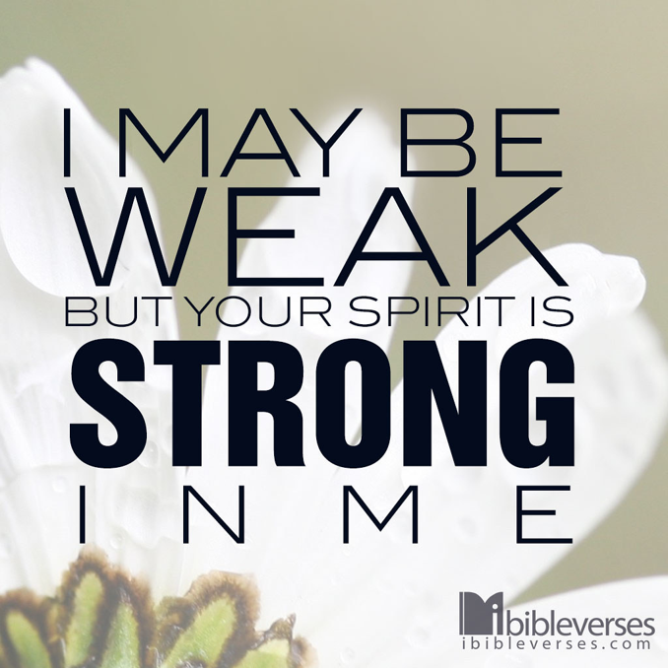

Sunday 4 October 2026
John Ormsby

“Becoming Strong in Spirit”
Luke 1:80

WHAT’S ON
Men’s Prayer Breakfast

Join the men of St Paul’s for the monthly breakfast on Saturday, 4 October from 7:30am. For more information, please reach out to Paul 027-423-0836

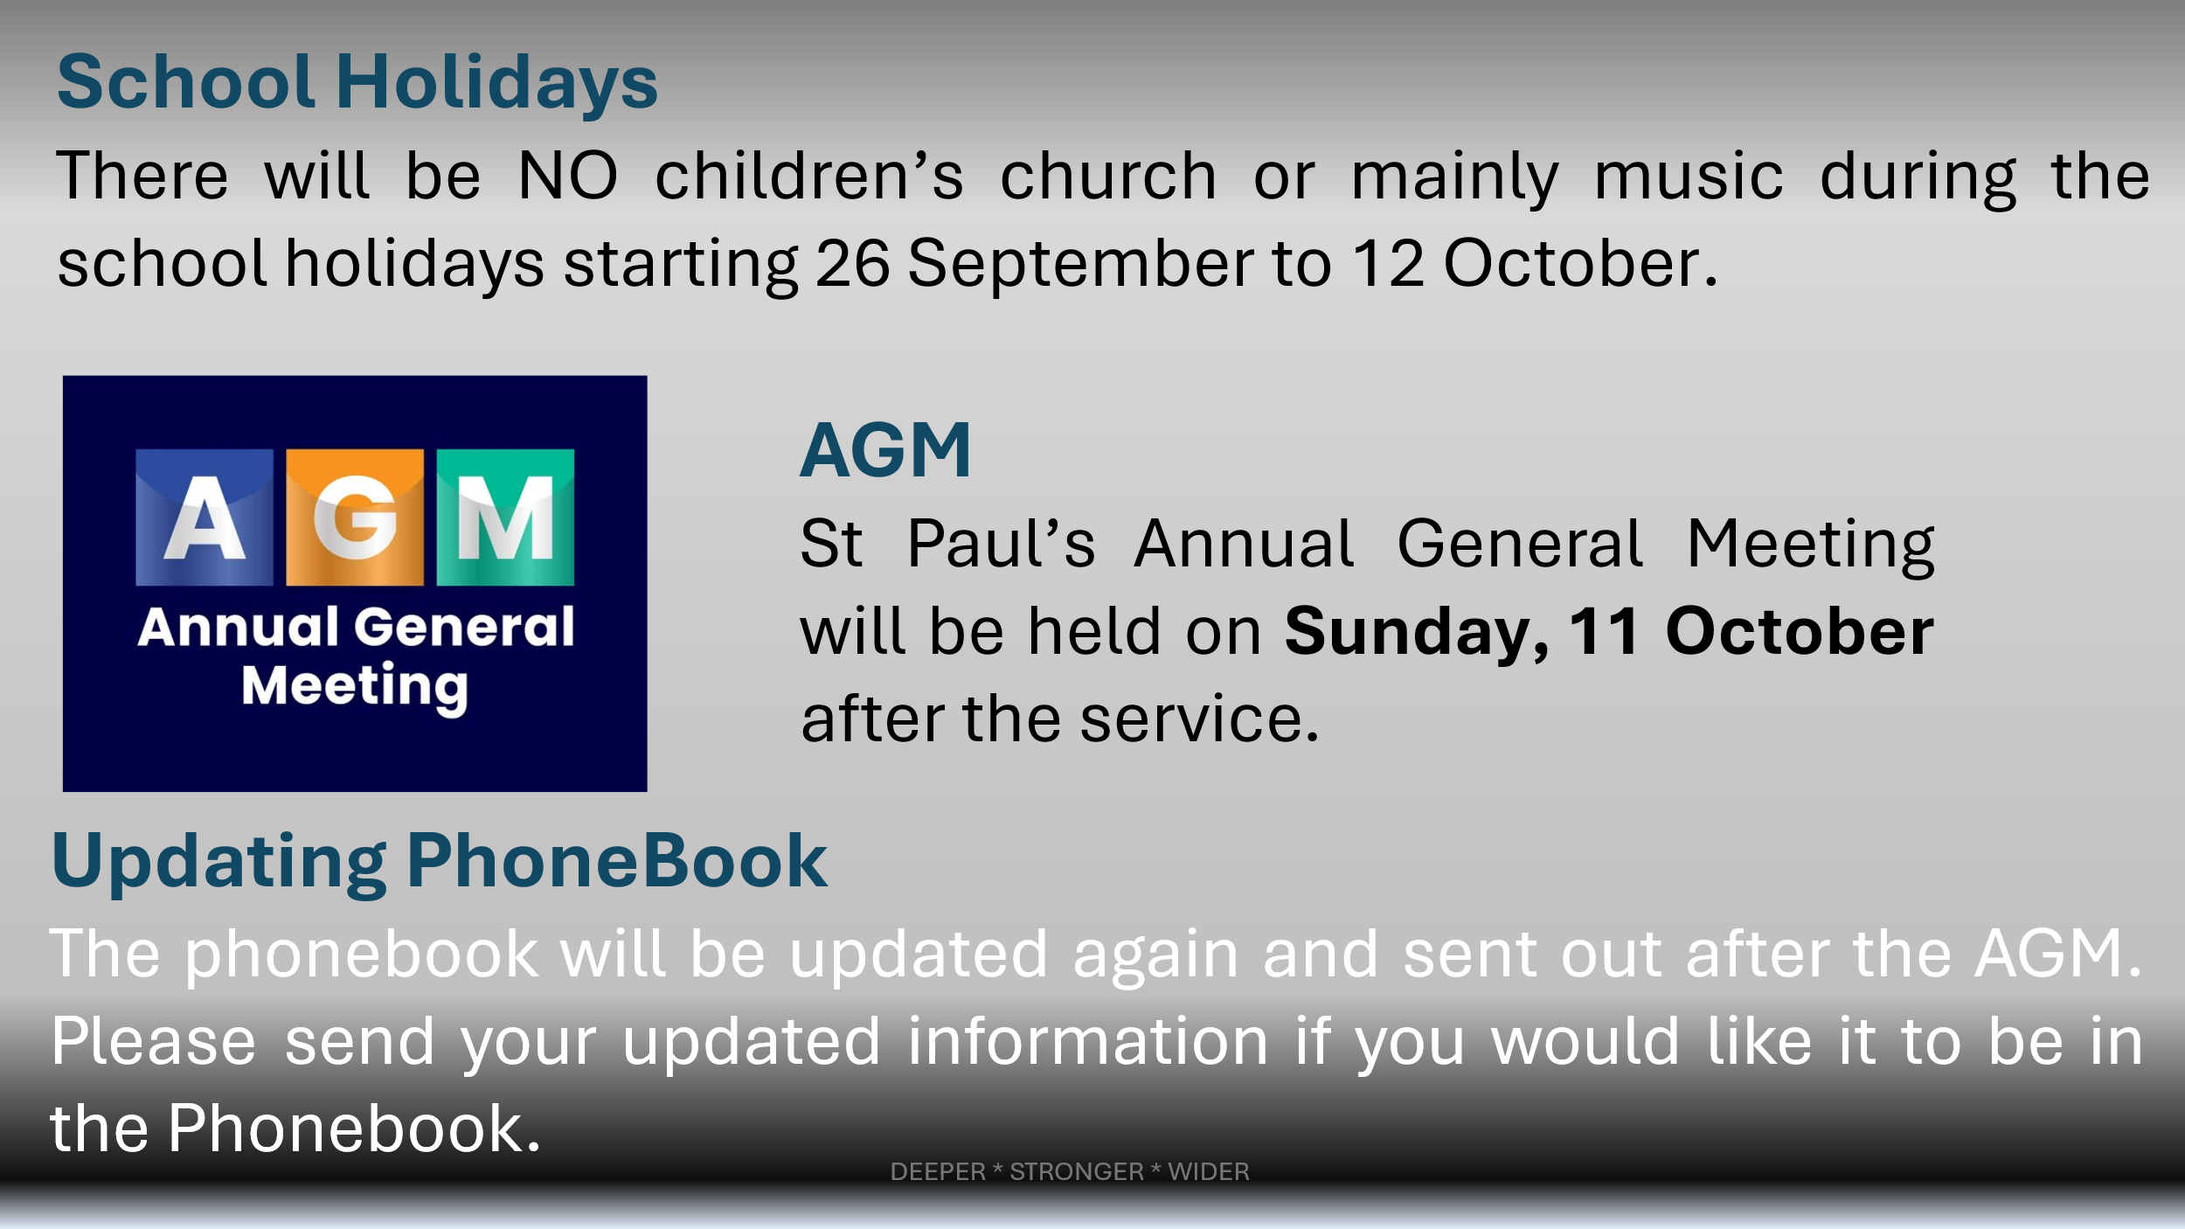


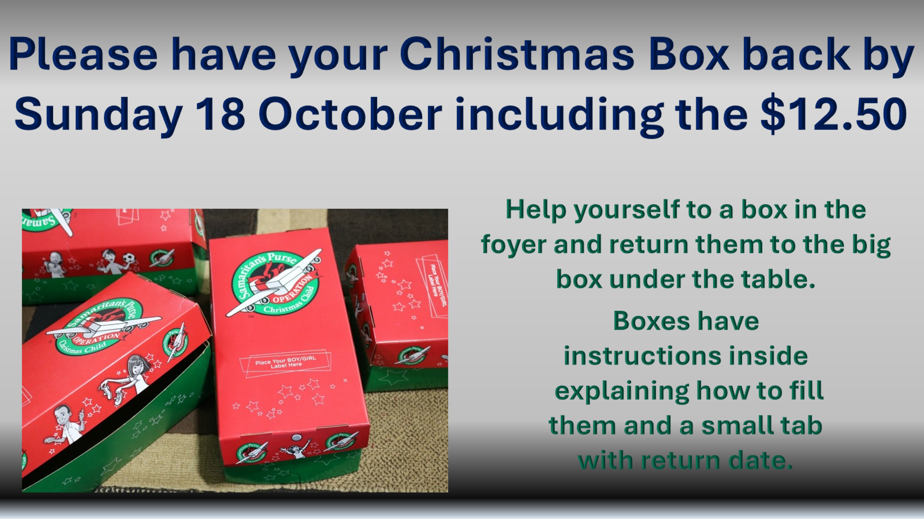

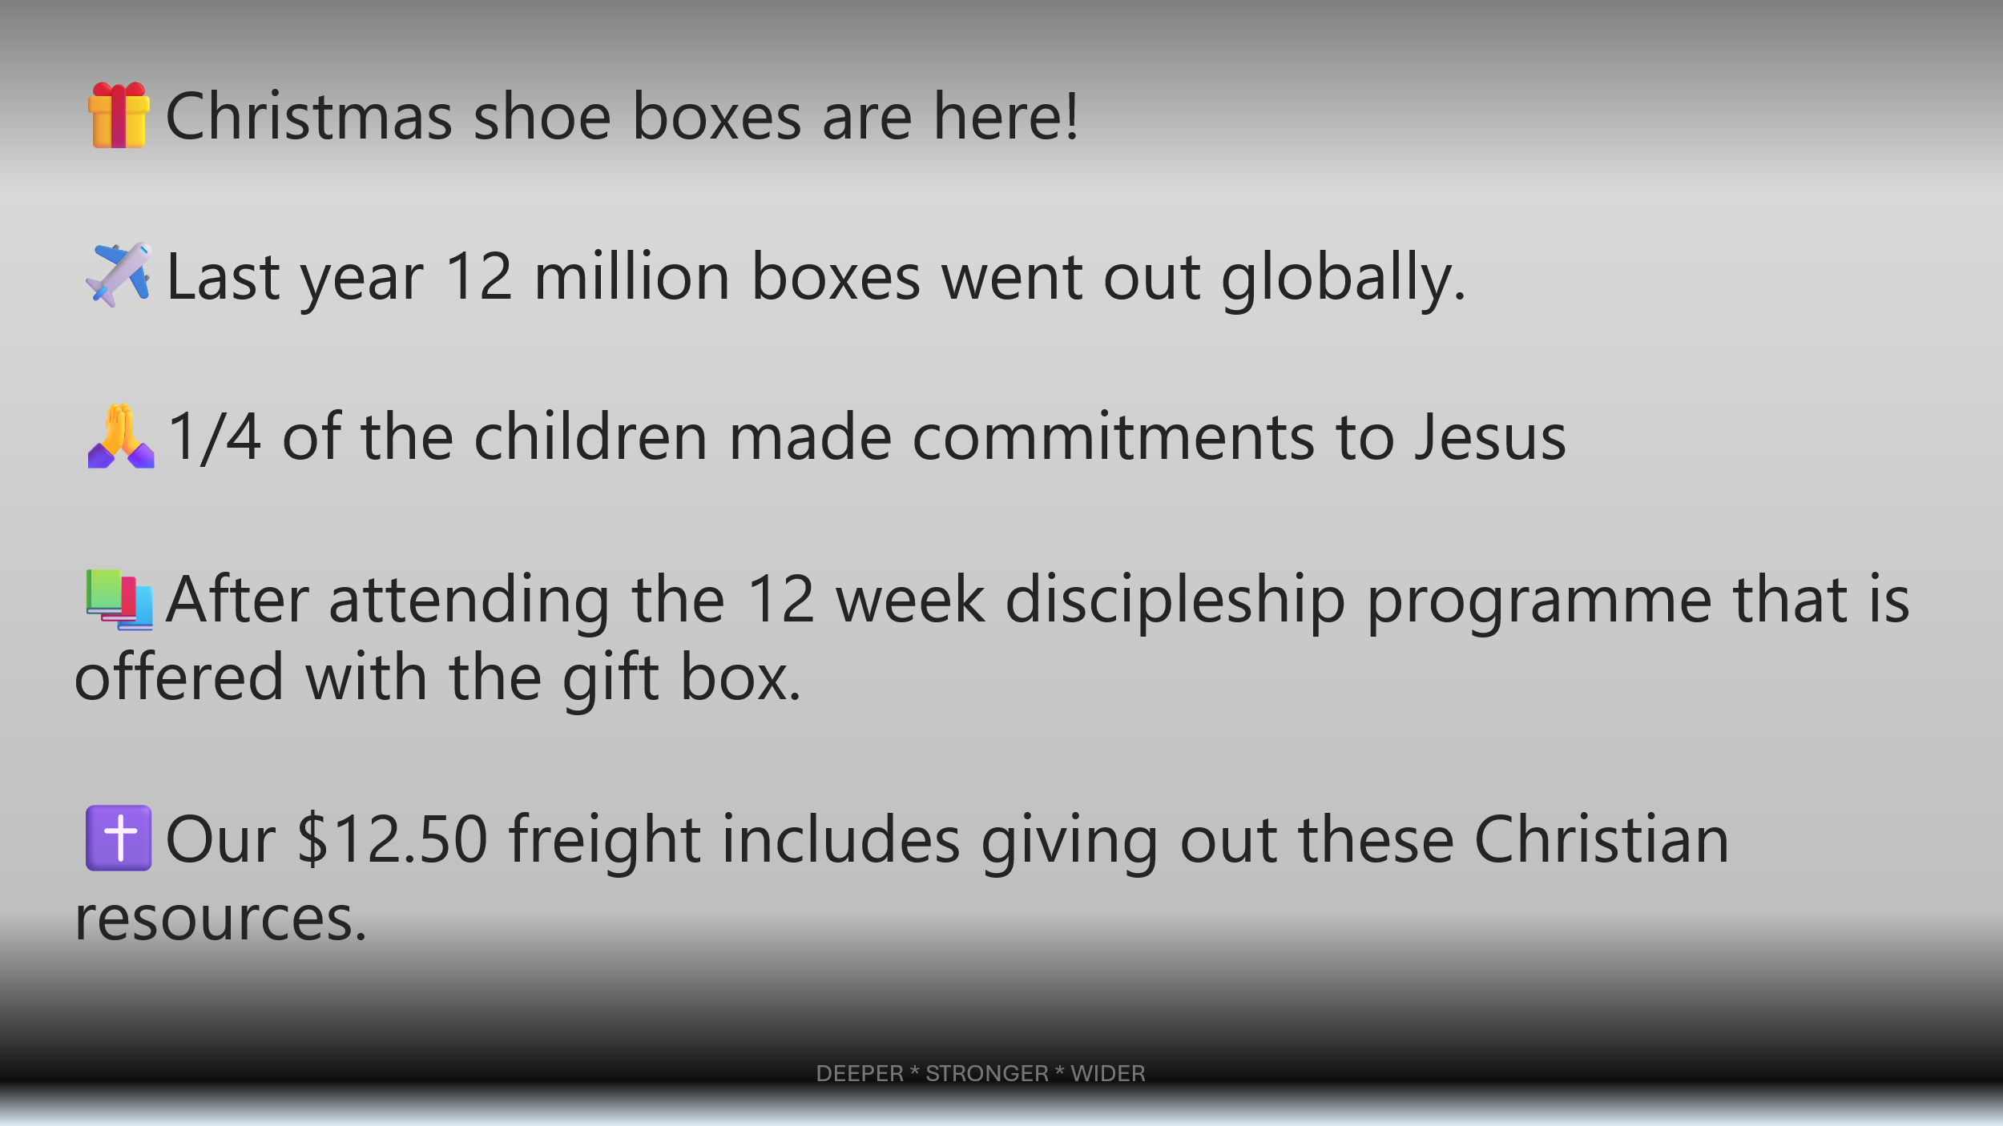



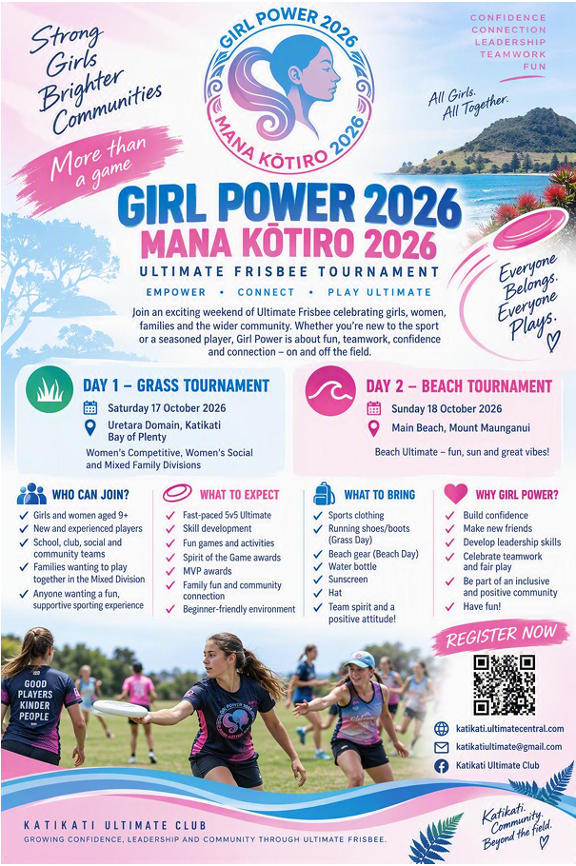
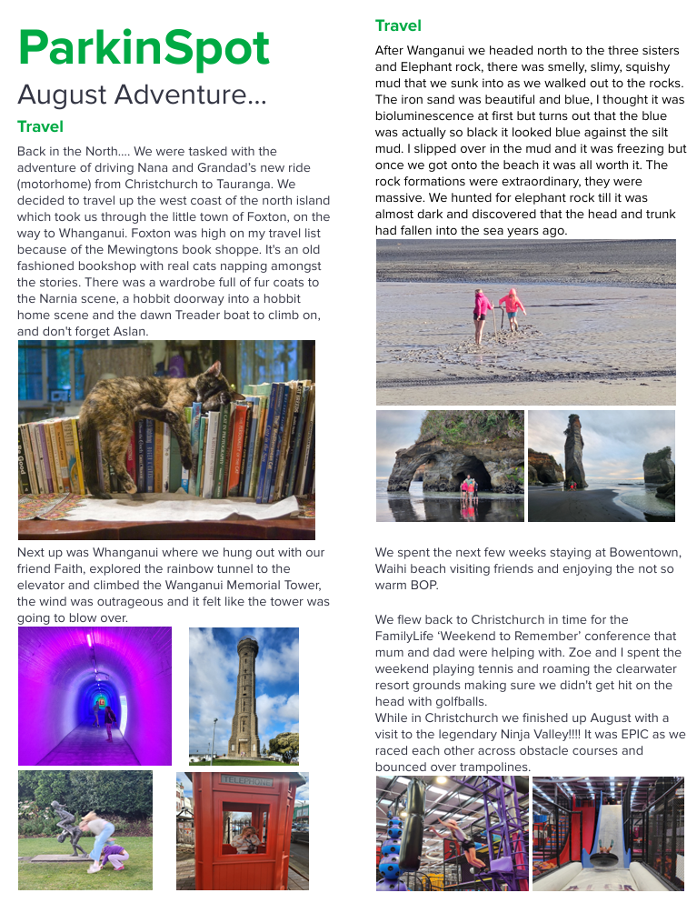
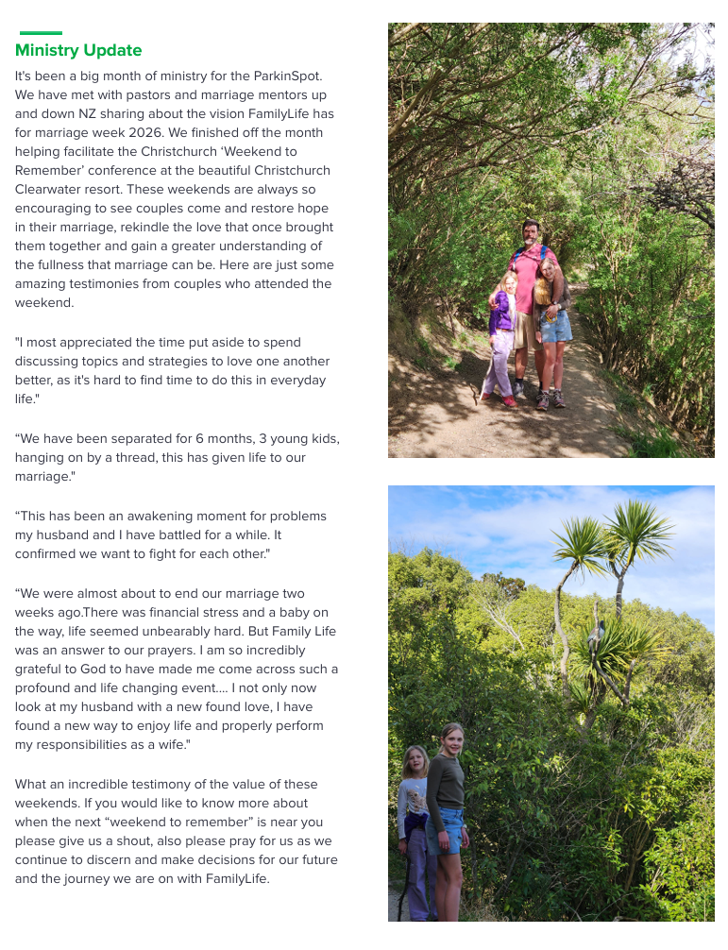


Baptism

Baptism is an important part of what it means to follow Jesus. If you are interested and want to know more, please talk with Ken Harray or our Session Clerk, Vanya Wallis.
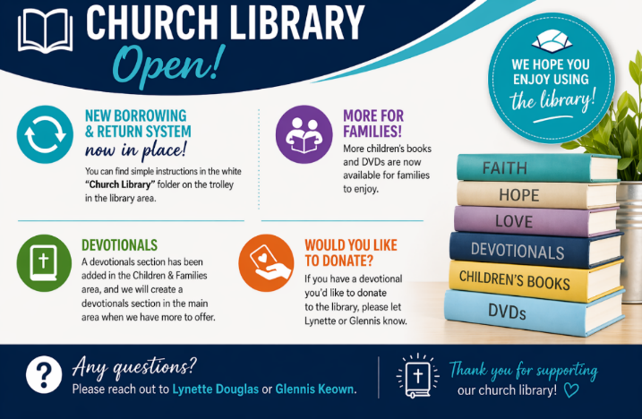

CHURCH GIVING AND BANK ACCOUNT DETAILS

If you wish to set up an automatic payment or donate to St Paul’s, please use the following details:
Katikati Presbyterian Church, 02-0340-0013449-00
We don’t take up an offering during the service. If you would like to give, please use the wooden box in the foyer. Thank you.
Month | Incoming | Outgoing | Difference
September | $31,923.65 | $51,937.57 | $20,013.92

Prayer

Every Tuesday morning from 8:30 in the meeting room. Sunday mornings before service in the Chapel from 9am. Reflectively before service in the auditorium.
Use the Chapel any time during office hours.
Just please sign in and out at reception. For specific prayer requests, contact Vanya/pastoral team.

For more information on St Pauls and what we are about and what we do, please visit our website. Home | St Paul's Presbyterian Church Katikati

SMALL GROUPS

Monday Afternoon - Monday afternoon from 1.30pm to 3.00pm at 34 Longmynd Drive, Katikati. Contact Alison 027 662 3246 or Paul Parish on 027 423 0836.

Bible Study at the Foris Home Group – 44 Ballantyne Way, Mondays 7pm. Ph 07-549-3346. On 31 August we will be starting an exegetical study on the book of Jonah. All are welcome.

Tuesday Morning Prayer Meeting – In the meeting room at 9:30

His Youth

Friday nights from 7-9pm for Youth 12 and older (Year 8 and up) at St Paul’s Church – during term times only

Mainly Music
This is a fun music and movement group for pre-school aged children and their parents or caregivers. Friday morning (except school and public holidays). A door charge of $3 per child, $5 per family. Contact Cheryl Harray
mainlymusic@stpaulskatikati.org.nz or stpaulskkmm@gmail.com

Contacts

- Interim Moderator Ken Harray phone 022-476-7402
email minister@stpaulskatikati.org.nz
- Session Clerk Vanya Wallis phone 0212301741
email session@stpaulskatikati.org.nz
- Children’s and Families email: stpaulscfm@gmail.com or session@stpaulskatikati.org.nz
- Treasurer Dirk email treasurer@stpaulskatikati.org.nz
- Office Administrator Karen admin@stpaulskatikati.org.nz Office hours Tuesday-Thursday 10am - 3pm phone 07-549-0098
- Church Bookings and Notices for Newsline
Email: admin@stpaulskatikati.org.nz
Newsline deadline Thursdays 12pm
- His Youth Leiona. hisyouth@gmail.com 022-349-5512
- Pastoral Needs Althea Ormsby 021-071-9549
email althea.ormsby@gmail.com
Glennis Keown phone 021-072-6210 email glennz54@hotmail.com

