EVENTS

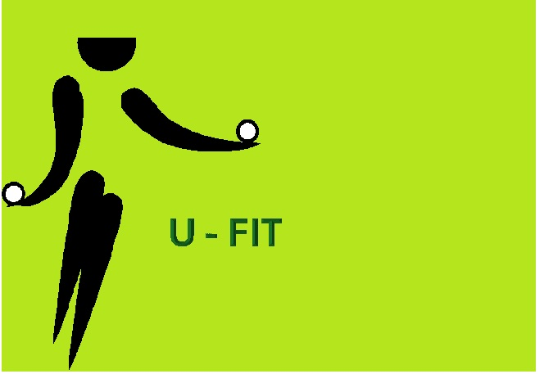
A Functional Fitness Class for men and women.
Mondays 9am-9:45am for men and women. Gold coin donation please. For more information contact Karen at karen.ufit@gmail.com

